**Question 2**

There are no special usage instructions. The CASE,IF, and CONCURRENT _ASSIGNMENT modules are all implemented in ***Question2.v***. The testbench was run with several numbers, starting with:

**NUM1 = 8, NUM2 = 4.** The results should be, based on select:

**SELECT = 0: RESULT = 8 + 4 = 12 or 0x0c**

**SELECT = 1: RESULT = 8 – 4 = 4 or 0x04**

**SELECT = 2: RESULT = 8 * 4 = 32 or 0x20**

**SELECT = 3: RESULT = 8 shifted left 4 times = 8 * 16 = 128 or 0x80 hex**

**SELECT = 4: RESULT = 8 shifted right 4 times, or 0**

**SELECT = 5: RESULT = (0100 & 1000) = 0**

**SELECT = 6: RESULT = (0100 | 1000) = 1100 = 0xC or 12**

**SELECT = 7: RESULT = (0100 ^ 1000) = 1100 = 0xC or 12**

**SELECT = 8: RESULT = !(0100&1000) = 0xFF, or 255**

**SELECT = 9: RESULT = - NUM1 = -8 = 0xF8**

**The results were consistent with these values:** 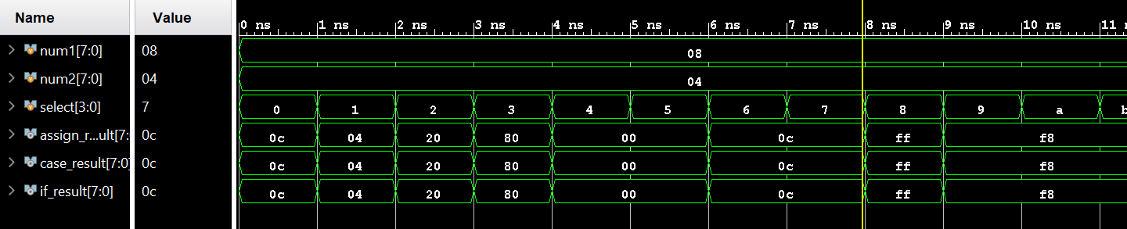

**9 and 7 were also used later:**

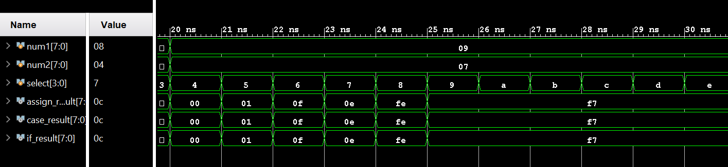

**And 10 and 15**

